Visual Verification
A Conceptual Overview

General Notes
Visual Verification (VV) verifies whether screen content (a snapshot) is within the tolerances of a reference snapshot. The core VV terminology is:
- Snapshot: A pixel buffer used for representing and evaluating screen image data.
- Verifier: An oracle object which determines whether a snapshot passes against specified inputs.
- Actual: The snapshot being evaluated.
- Master: The reference data (image) which is used to evaluate the actual snapshot.
- Tolerance: The accepted bounding range based on which the actual snapshot will be accepted as valid.

Visual Verification Workflow
The fundamental scenario for Visual Verification is to capture screen content and compare it against a known good image. The diagram below outlines the typical visual verification workflow:
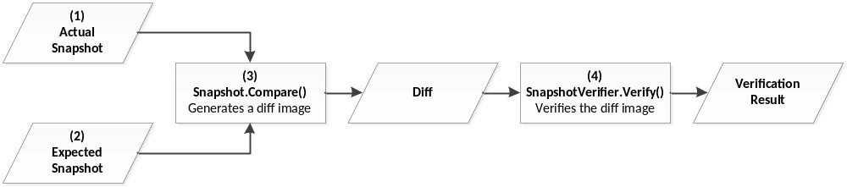
Figure 1 Typical Visual Verification workflow

Verifier Technology
TestApi provides the following Verifier technology:
- SnapshotColorVerifier. Reports passing if every pixel of the verified image is within a user-specified tolerance range of a target color.
- SnapshotHistogramVerifier. Reports passing if the histogram of the (diff) image falls under the curve of a reference image histogram. This technique is helpful for allowing small quantities of noise pixels in an image that is otherwise identical to the master image.
- SnapshotToleranceMapVerifier. Reports passing if the every pixel of the verified image has lower color values than the corresponding pixel in the “tolerance map”.

Example – Visual Verification Using SnapshotToleranceMapVerifier
When doing visual verification, it is often necessary to verify specific parts of a window with high accuracy, while at the same time confirming that the rest of the window looks reasonably close to expectations.
Consider for example an application with the following UI:

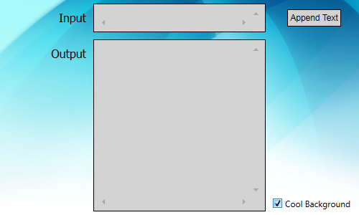
Figure 2a Actual snapshot of the application UI

If we wanted to verify the UI of this application using visual verification, we would take a snapshot, compare it to an expected known good snapshot (Fig. 2b), and then evaluate the diff image (Figs. 2c and 2d).
We will soon discover that the diff image will tend to vary a bit, on different OS and HW configurations. Furthermore, most of the variation would occur around the text regions in the application window (ClearType renders differently on different machines).
One way to work around that phenomenon, is to increase the tolerance (or completely mask away) those regions, providing of course we are not specifically interested in their rendering. Fig. 2e shows a possible tolerance map image that can be used for visual verification purposes.

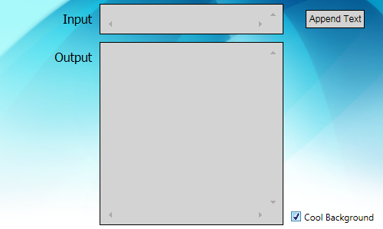  Figure 2b Expected snapshot | 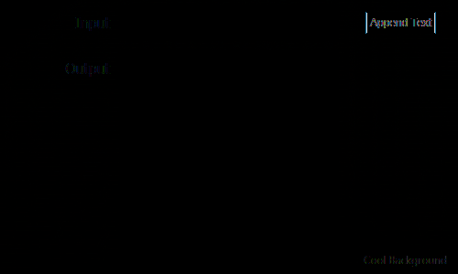  Figure 2c Diff image | 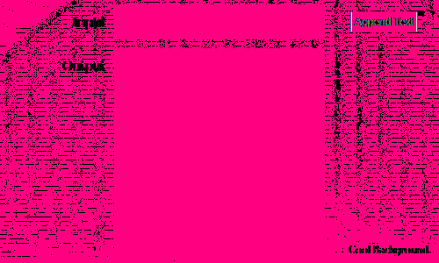  Figure 2d Diff image, with completely black pixels are replaced with pink |   Figure 2e Tolerance map

The following code demonstrates how to use SnapshotToleranceMapVerifier for visual verification purposes.

// Take a snapshot, compare to the master image and generate a diff
WindowSnapshotMode wsm = WindowSnapshotMode.ExcludeWindowBorder;

Snapshot actual = Snapshot.FromWindow(hwndOfYourWindow, wsm);
Snapshot expected = Snapshot.FromFile("Expected.png");
Snapshot difference = actual.CompareTo(expected);

// Load the tolerance map. Then use it to verify the difference snapshot
Snapshot toleranceMap = Snapshot.FromFile("ExpectedImageToleranceMap.png");
SnapshotVerifier v = new SnapshotToleranceMapVerifier(toleranceMap);

if (v.Verify(difference) == VerificationResult.Fail)
{
// Log failure, and save the actual and diff images for investigation
actual.ToFile("Actual.png", ImageFormat.Png);
difference.ToFile("Difference.png", ImageFormat.Png);
}

The above sample demonstrates just one possible verification strategy. SnapshotHistogramVerifier and SnapshotColorVerifier provide other possible verification strategies for visual verification.

